

Daffodil International University

Department of Computer Science and Engineering

Faculty of Science and Information Technology (FSIT)

Mid Term Examination, Semester: Spring - 2017

Course Code: CSE311 (Day) Course Title: Database Management System

Section: All Course Teacher: All

Time: 90 minutes Total Marks: 25

Answer all questions

**Consider the following scenario to answer Q1: 8**

Bangladesh is bestowed by spectacular Natural Beauties. We can see the glimpse of natural beauties through our numerous tourist spot. Tourist spots which are at country side rather than close to city are aesthetically more beautiful. Simple inhabitants, beautiful landscapes, serenity are some of the remarkable features of these places. We can differentiate tourist spots by their names. Visiting country side spots are less costly than city side spots. You can visit these spots by your own arrangements or by different travel agencies. Agencies are uniquely identified by their agency id. Each travel agency normally operates on a particular region. These regions normally comprises of several tourist spots within short radius. That’s why travel with these agencies are very useful. Bangladesh Parjatan Corporation(BPC) is trying to improve the ambience of these spots and also takes steps to promulgate these spots not only towards local tourists but also foreign tourists. Tourists travel different tourist spots and they are identified by their Passport number.

**Q1:** Propose an Entity Relationship diagram that represents above information. Be sure to mark the key attributes and include cardinality constraints on relationships.

**Consider the following ER Diagram to answer Q2: 4  
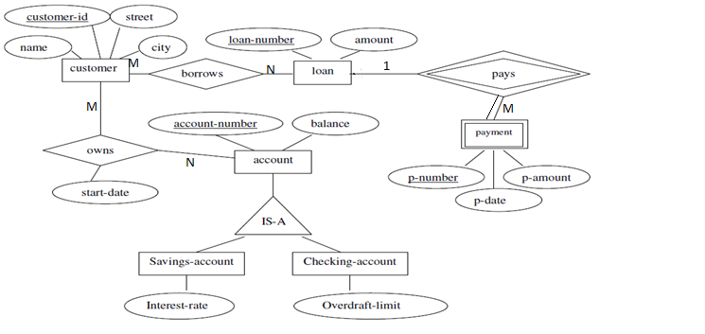Q2:** Convert the ER diagram into a relational database schema. Be certain to indicate primary keys and foreign keys.

**Consider the following schema to answer Q3:** **8**

Consider the following schema for a database where the primary keys are given. Give an expression in SQL for each of the queries.

**University** (uName, state, enrollment)

**Student** (sID, sName, GPA, sizeCS, admissionDate)

**Apply** (sID, uName, Major, decision)

Here, in the University table *enrollment* attribute represents numbers of students registered into that university. In the students table *sizeCS* (College Size) attribute represents the numbers of students of the College from where the student is coming.

1. Add another field in Student table, named as “Email” and give the data-type of that field as variable character which must be size of 10.
2. Find the name and GPA of students who came from a College with less than a 1000 students and applied to major in CSE.
3. Find the minimum and average GPA of students who have applied for a CSE major.
4. Show all the majors name where the highest GPA of a student applying for that major is lower than 4.00.

**Q4:** a)What are the different types of attributes in an entity? Briefly explain them. **3+2** b)What is ACID properties in Database Management System? Explain the last property.